**BS. INFORMATION TECHNOLOGY**

**PDL MANAGEMENT SYSTEM – FLOWCHART**

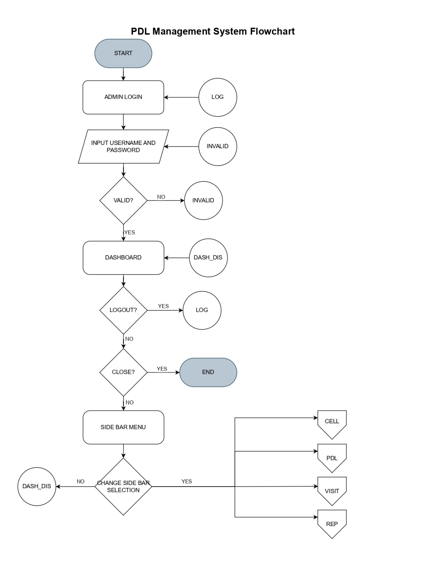

Prepared by:

**Leader: JUSTINE NORIE B. DELA CRUZ**

**Group 2 – PDL Management System**

Checked by:

**JEPCHION EVANGELIO**

**BS. INFORMATION TECHNOLOGY**

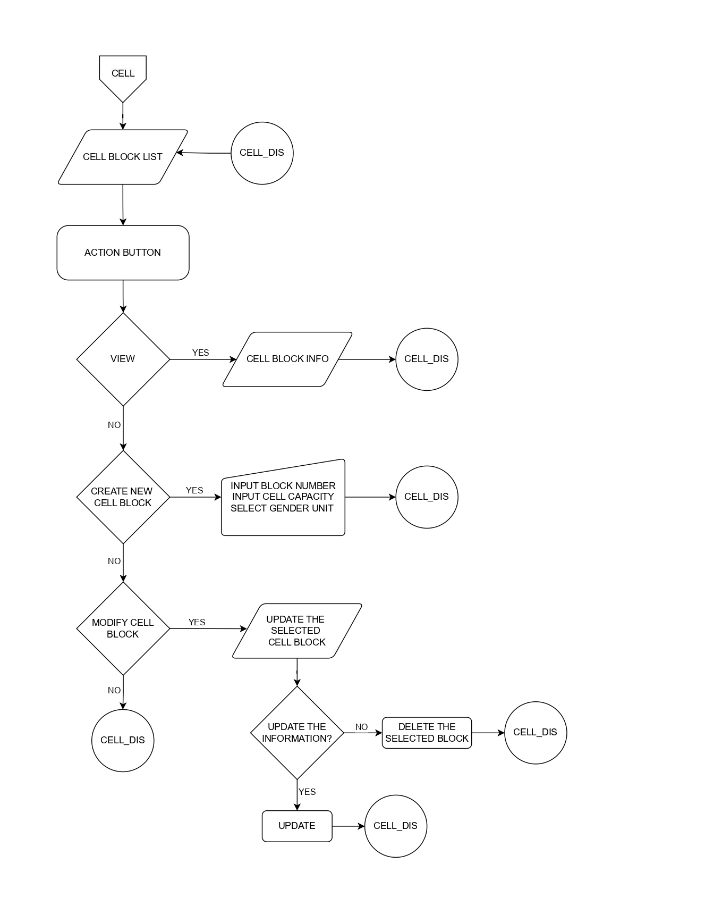**PDL MANAGEMENT SYSTEM – FLOWCHART**

Prepared by:

**Leader: JUSTINE NORIE B. DELA CRUZ**

**Group 2 – PDL Management System**

Checked by:

**JEPCHION EVANGELIO**

**BS. INFORMATION TECHNOLOGY**

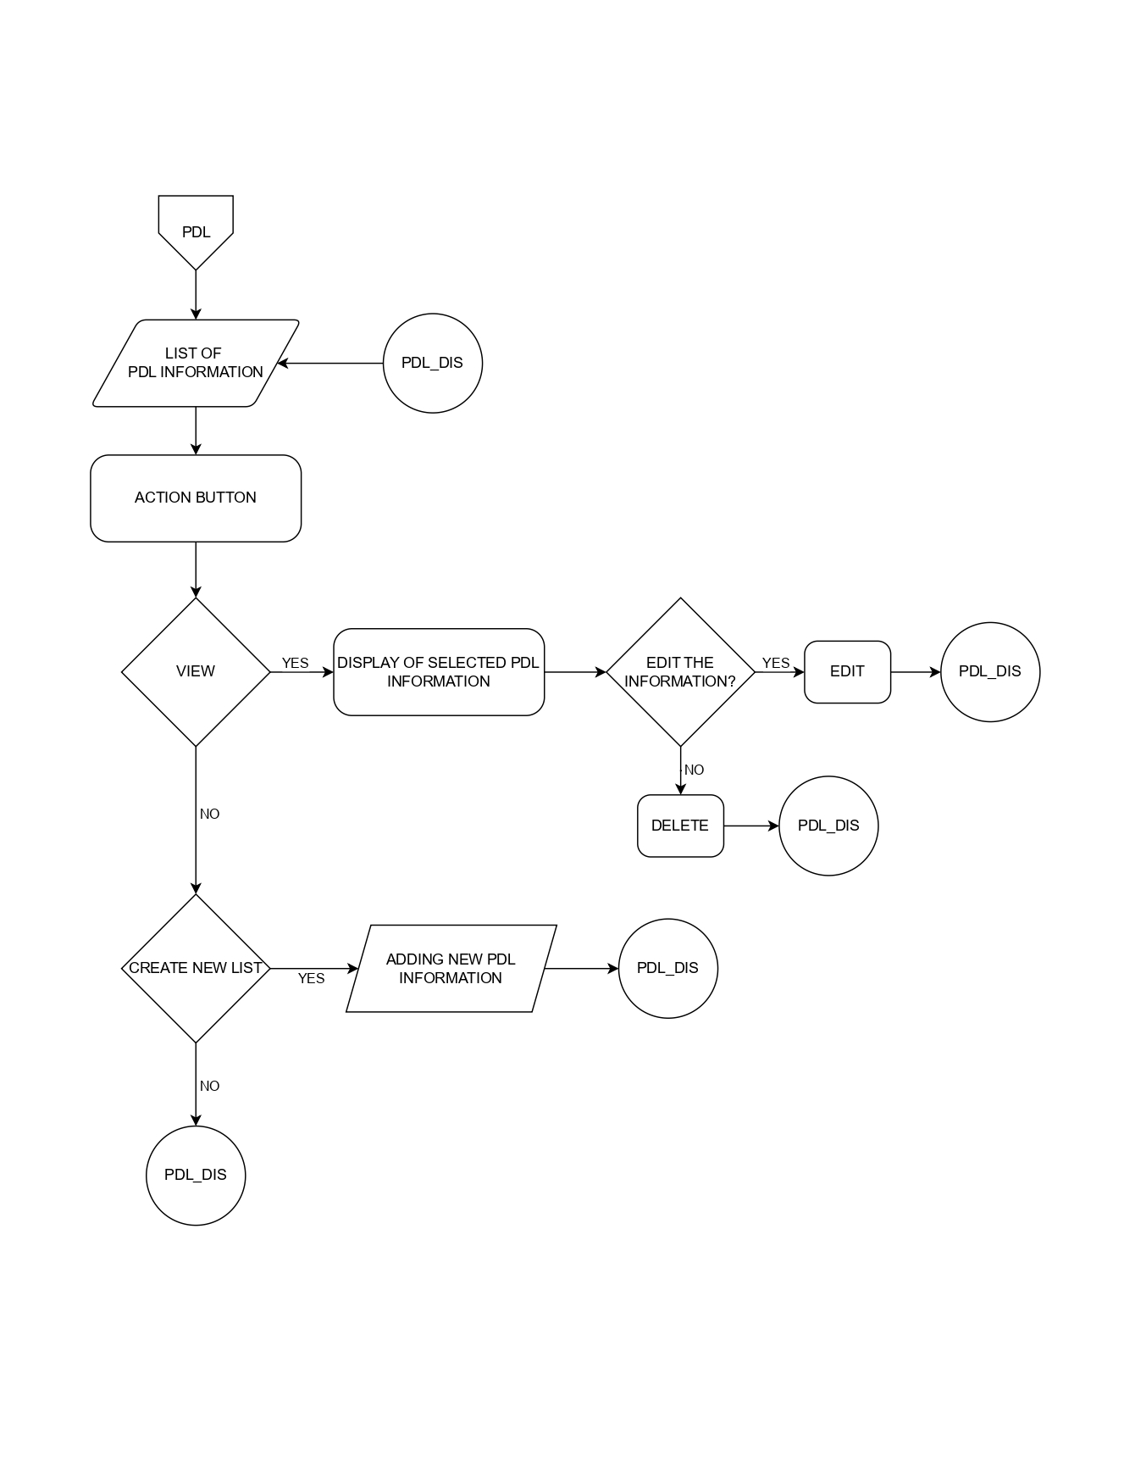**PDL MANAGEMENT SYSTEM – FLOWCHART**

Checked by:

**JEPCHION EVANGELIOz**

Prepared by:

**Leader: JUSTINE NORIE B. DELA CRUZ**

**Group 2 – PDL Management System**

**BS. INFORMATION TECHNOLOGY**

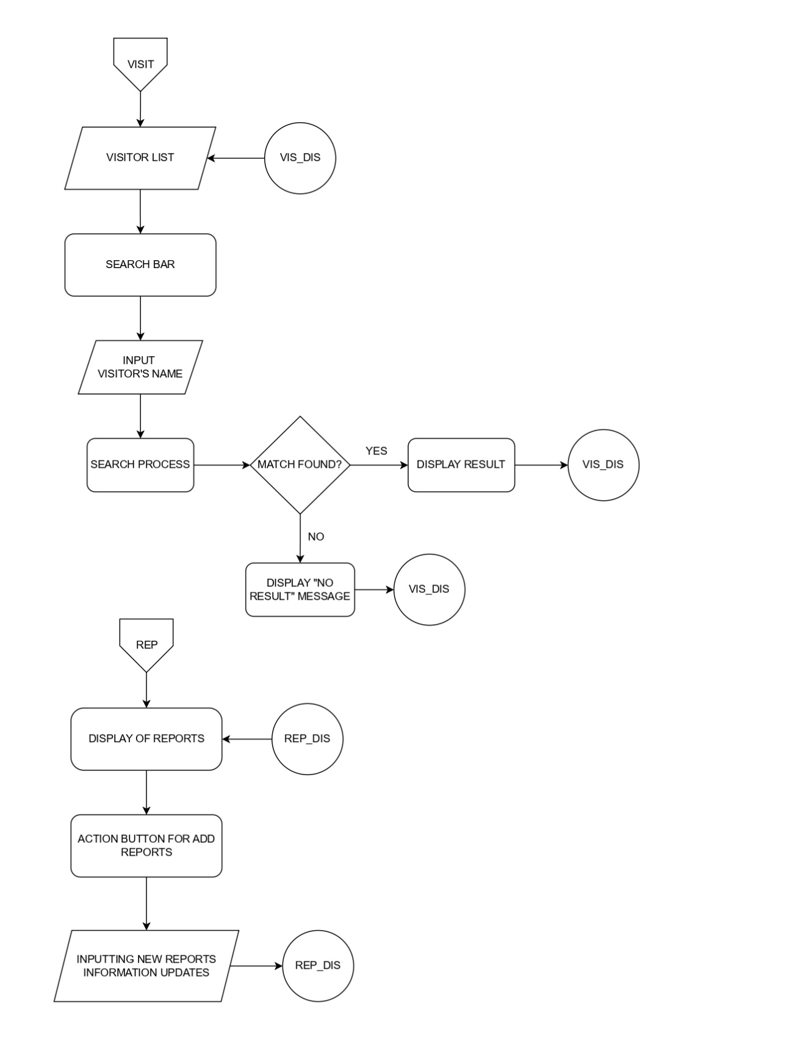**PDL MANAGEMENT SYSTEM – FLOWCHART**

Prepared by:

**Leader: JUSTINE NORIE B. DELA CRUZ**

**Group 2 – PDL Management System**

Checked by:

**JEPCHION EVANGELIO**

